Jake Lake
Web Site Analysis
ECT-455-910
Rhoel P Lomahan
Site: www.zappos.com
Zappos has followed an online-only business plan for the past ten years but has recently opened two outlet stores to assist their customers’ needs. The business model that Zappos uses is one that can really be called a loyalty business model where they base most of their sales opportunities on word of mouth advertising and repeat customers. According to Nick Swinmurn, the founder of the company, “60% of our customers are repeat buyers, and 25% of the rest buy after hearing about us from friends or family”.
Zappos value propositions are, in the same light as their business model, based almost entirely on service value added and include free shipping, free returns, a 365-day return policy, and a call center open 24/7 that also features Spanish speaking operators. They promise 4-day shipping with all orders but next-day ship most of their orders to pleasantly surprise customers and if you call their service center they will upgrade your account to VIP status for free resulting in all orders shipped next-day. Their web interface does a really good job of listing their value propositions as are shown by the red boxes in figure 1.
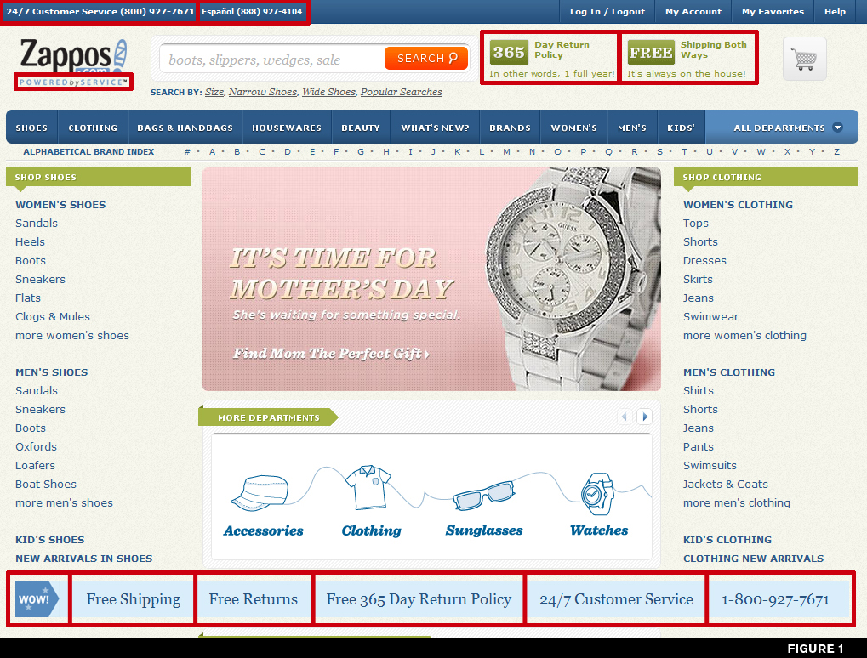Zappos main competitors consist of shoes.com, endless.com, piperlime, and shoesgotsole.com – all likewise online retailers of shoes.
The only other channels available aside from the website are as currently mentioned the newly opened outlet stores in Louisville, KY and Las Vegas, NV.
The intended customer base for Zappos includes men, women and children – everyone and anyone in need of a new pair of shoes for any occasion. Zappos goes so far as to create classifications for all sorts in order to hit almost all possible audiences in need of shoes ranging from gender, age, size, lifestyle, occasion, size (width), sale, brand, color, laces, and otherwise.
Advertising for Zappos is rather non-existent in the traditional means of paying for ad-space although they do have an occasional television commercial to market their superior service. Rather than advertise, as their founder Swinmurn states, “… we spend our money on fast shipping that is free to the customer. We also pay for free returns whenever needed”
The site hits all of the customer types in a few different ways. In order to reach the impulsive buyer, there are many beautiful images of shoes on every page with prices listed vividly to the right of the shoe.
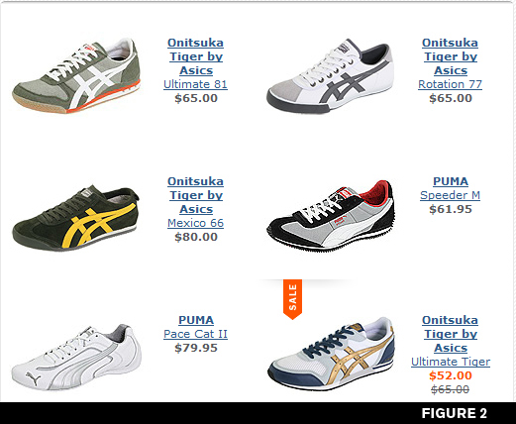
They also have a sale/clearout section that lists the original price of the shoe along with the discounted price so the user will know the amount they are saving.
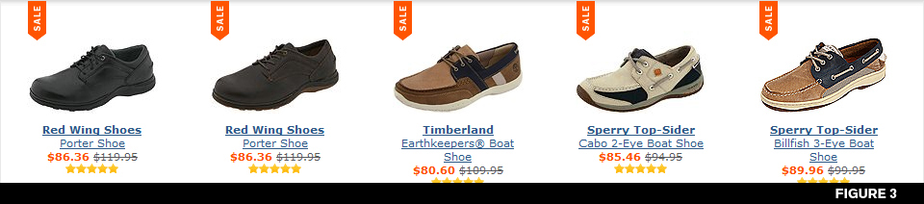For the patient customer, the site allows for the creation of a favorites list of shoes (after having created a login account). With your favorite list you can watch to see if the prices fluctuate. They also allow for telling a friend about the shoe, sharing it via email, or even creating a badge to throw on a blog along with the option for a short link to reach the product http://zapp.me/####.
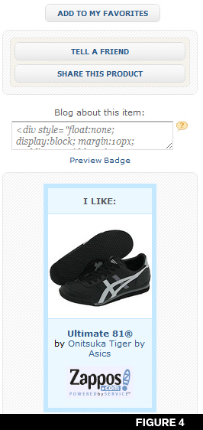
The last cool feature they include to grab the patient buyer is the capability to add a certain brand to your favorites and to have the site notify the user when new styles of that brand are added to the store.
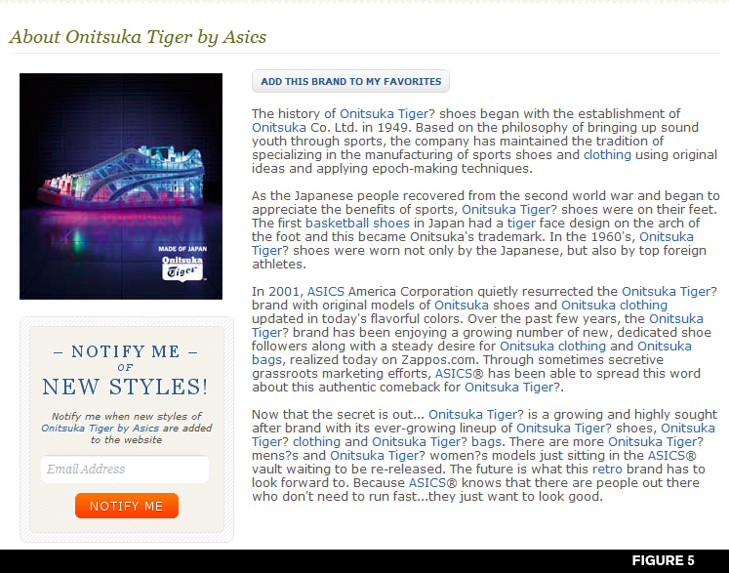To reach the analytical buyer, there is a multitude of features including showing what other customers who bought the product you are looking at purchased and what other customers who viewed a certain item also viewed.
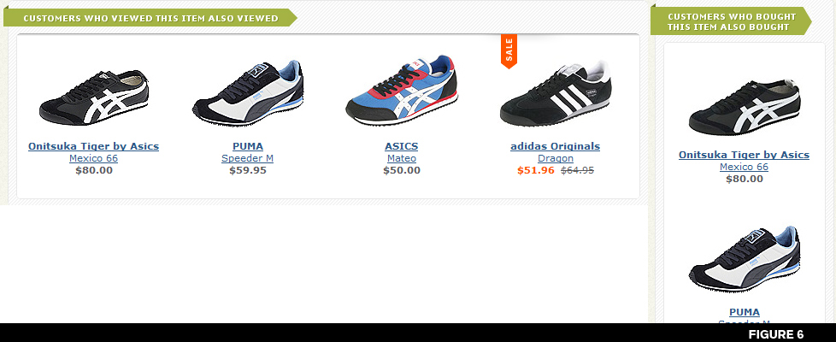On top of that are listed customer reviews of each product on the product page with rankings for overall, comfort, style, how true to size the shoe fits, how good the shoe arch is, and whether or not the shoe width is true to fit along with a comment section from other owners.
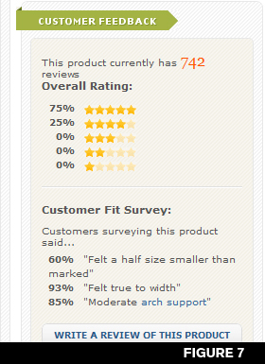
Their other key feature for reaching the analytical buyer is the product information given by Zappos themselves in which they list of a lot of key figures about the product and also in many cases provide a video description of the product.
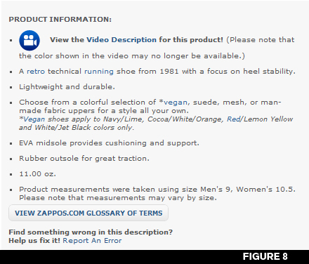
A few web 2.0 additions to the site include the standard search bar that also lets you know popular searches and after searching provides options for narrowing your field more, upon picking a color/size combination for a shoe the site automatically updates letting you know whether or not this is available prior to attempting to add it to your shopping cart and in the event that it is unavailable they do not allow you to add it into the shopping cart, they offer a live chat with a sales representative to answer any questions online, the ability to share a product on your blog, customer feedback on each product page including review comments, reviews, and votes on other options as previously mentioned, RSS feeds, and a rather google-esque total count of brands, styles, and products listed at the bottom of each page.
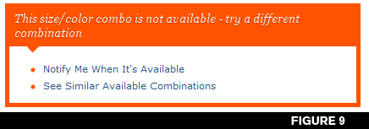
Checking out is possible via the Zappos site or through PayPal. If you go the Zappos route it is required that you create an account or login with your previously created account. Upon logging in or creating an account you are taken to the final step in checking out – to verify shipping and payment information. Shipping is listed as free for standard 4 day (and can assumed to be upgraded to overnight for free), it lists your shipping address, payment information, and your order summary including the product, size, price, quantity, color, and width followed by subtotal, shipping fee, tax, and a grand total. It then shows a Submit My Order button that underneath notes, “Please press “Submit My Order” only once. Your payment method will be charged.” Letting you know that this is the first and last step in the process. Delivery, shipping, and processing, are as previously mentioned free and almost always upgraded to overnight with no added costs.
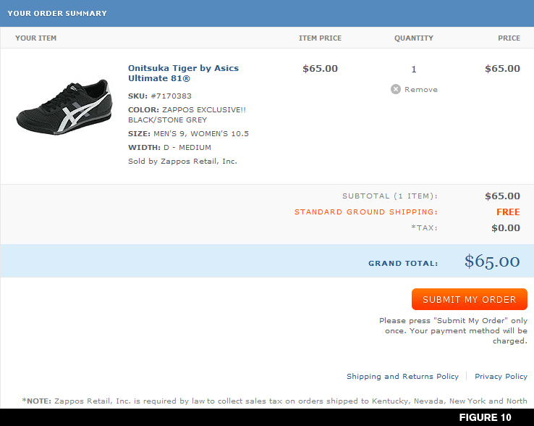Zappos use of customer reviews, free shipping, free returns, 24/7 customer support line that is answered by real English speaking Americans, and incredible shipping upgrades to overnight most of the time are the real drive behind the company and the way that they keep their customers returning via great service.
The website is incredibly intuitive and simple to use. Things are laid out in an easy to navigate fashion that is not only easy on the eyes, but easy on the senses. In the past the site used a rather poor color scheme, but it seems as though in recent times they’ve smartened up and changed to a deeper blue that really makes their site feel a lot stronger.
The sites listings, pictures, and beauty provide the hedonic experience for someone just surfing the net for shoes or for web layouts. It also offers a very useful buyer experience in that it is simple to find the shoe you want and to purchase it.
Two enhancements that I could see being beneficial for Zappos would be for one to offer price comparisons to their competitors. If you call them, they will do it, and if they are out of a size of a shoe – they will find it for you from one of their competitors – to know that they do this on the phone seems kind of silly that their website does also not support it. Another thing to be added could be having a check-out in which registration was not required at all to further assist those impulsive buyers to purchase what ends up in their shopping carts.

“BBBOnLine Update.” Welcome to BBBOnline. June 2005. Web. 08 May 2010. <http://www.bbbonline.org/update/issue.asp?ID=53>/>.
“BBBOnLine Update.” Welcome to BBBOnline. June 2005. Web. 08 May 2010. <http://www.bbbonline.org/update/issue.asp?ID=53>/>.

