ECT 455 E-Commerce Web Site Engineering

Deliverable C

Technical Requirements

Green Team

4/25/2010

Table of Contents

1. Project Description 4
1.1 Objectives 4
1.2 Goals and message, 4
1.2 Content 4
1.4 Structure and Interpretation 4
1.5 Sensorial design 4
1.6 Market testing 5
1.7 Potential Challenges 5
1.8 Strengths 5
1.9 Opportunities 5
1.10 Target demographic 5
2. Impact Assessment 5
3. Implementation Strategy 6
3.1 Planning--3/31/2010-4/7/2010 6
3.2 Analysis-4/7/2010-4/21/2010 6
3.3 Design-4/21/2010-5/26/2010 6
3.4 Implementation-5/25/2010-6/9/2010 6
4. Functional Requirements 6
4.1 Functional Requirements 6
5. Information Architecture 7
5.1 High-Level Site Map 7
5.2 High-Level Process Flows 8
5.2.1 Registration (TR 4.1.) 9
5.2.2 Login Process Flow (TR 4.2) 10
5.2.3 Calendar (TR 4.3) 11
5.2.4 Search Content (TR 4.4) 12
5.2.5 Message Board (TR 4.5) 13
5.2.6 Donation Process(TR 4.6) 14
6. Interface Requirements/Specifications 15
6.1 User Interface 15
6.1.1 Home Page 16
6.1.2 Mentor Biography Wireframe 17
6.1.3 Calendar Event Wireframe 18
6.2 Hardware Interfaces 19
6.3 Software Interfaces 19
6.4 Communications Interfaces 19
7. Information and Data Requirements 19
7.1 Data Requirements 19
8. Non-Functional and Support Requirements 19
8.1 Operational Requirements 19
8.2 Security Requirements 19
8.3 Approvals of Technical Requirements 20
Team Contribution 20
1. Project Description
Forever Moving Forward (FMF) is a non-for-profit organization whose purpose is to provide mentor guidance, educational assistance, and positive adult role models for youth in the Chicago Land area. FMF’s primary means of achieving its goal is by empowering children with knowledge, experience, and self-esteem. FMF’s goal is foster these youths such that they are able to enter the world as positive contributing members of society.

  - Objectives
Forever Moving Forward was established on the principles of fostering mentoring relationships with youth ages 7 to 18, providing educational opportunities and exposure, developing self-awareness/self-esteem, and creating self-sufficiency.

  - Goals and Messages
- Help young girls deal with the short and long-term challenges of being an adolescent, as well as, moving from adolescence to adulthood.
- Empower young ladies by providing them with the tools and strategies they need in an effort to make a difference in their lives.

  - Content
The site will contain the following elements:
- Home Page
- About Forever Moving Forward
- Mentor Biographies
- Contact Information
- Online Donation
- Calendar
- Message Boards
- Past Events Listing
- Photo Gallery

  - Structure and Interpretations
- Visitors will be able to find out about FMF’s organization; past present and future
- Visitors will be able to find out how to contact FMF
- Visitors will be able to see upcoming events that are open to the public
- Visitors will be able to learn about FMF volunteers
- Visitors will be able to see photos of past events
- Visitors will be able to register to receive emails of news and upcoming events
- Visitors will be able to make online donations to FMF
- Mentees will be able to view a calendar containing mentoring events
- Mentors and mentees will be able to post to the message boards
- Mentors and mentees will be able to create topics on the message boards
- Administrators will be able to update the calendar with new events
- Administrators will be able to remove post and topics from the message boards

  - Sensorial Design
- The Forever Moving Forward web site will employ a clean design with the content displayed in an orderly and concise fashion.
- The functionality of the site will be as simple as possible to cater to inexperienced users, while at the same time employing leading-edge technology.
- Industry-standard usability guidelines/heuristics will be used as a guide.

  - Market Testing
Because the business model of FMF is that of a non-for-profit mentoring organization the major competition are the following organizations:
- http://www.kinshipinc.org/
- http://www.bigsisterleague.org/
- http://www.mentoringcenterco.org/

  - Potential Challenges
- Creating an engaging web site that encourages the mentees to visit often to participate in online discussions and to seek help from other mentees and the mentors.
- Providing informational content about the organization and its activities that encourages visitors to donate time and/or money to FMF.
- Reliance on donations and grants for funding.

  - Strengths
- Experience and knowledge of volunteer staff
- Commitment and dedication of volunteer staff
- Relationships with individuals and organizations in the community

  - Opportunities
- Because there are not many organizations that focus on female youth in Chicago FMF has the opportunity to become a premier organization that reaches many young girls in the Chicago Land area.
- Due to many past and recent laws there is substantial grant money via government agencies that is accessible to non-profit organizations.

  - Target Demographics
- Young girls ages 7 to 18 in the Chicago Land area
- Middle-class and lower-class families in need of assistance with troubled youth
- Parents seeking positive role models for their children
- Philanthropists seeking to fund Chicago organizations

2. Impact Assessment
- The FMF web site will need to be available 24/7 for Chicago communities who are interested in the mentoring programs provided by FMF.
- This is a brand new site for a non-profit organization. Research needs to be done to find a hosting environment that fulfill the following requirements:
  - Hosting the web site 24/7.
  - Compatible platform.
  - Provides database storage.
- FMF needs to decide the domain name and purchase the domain name.
- FMF needs to create a PayPal account or register a credit card gateway in order to collect donation. Our team can research to help FMF make the decision.
- FMF needs to staff web writers to update web site content periodically.
- FMF needs to staff or consider contractor or volunteer for web site maintenance, such as upload new content and expand functions as the organization grows.
- FMF needs to provide training to mentees/parents how to use the web site after it goes alive, such as registration, login and message board, etc.
3. Implementation Strategy
3.1. Planning 3/31/2010-4/7/2010
- Form a team
- Identify team members’ roles
- Determine target client

3.2. Analysis 4/7/2010-4/21/2010
- Business case analysis
- Technical specification requirement analysis
- Determine platform/programming language
- Determine production host environment
- Determine method to collect online donation

3.3. Design 4/21/2010-5/26/2010
- Prototype navigation structure, content presentation and visual components.
- Prototype login, registration, calendar, message board and donation process.
- Invite clients to review the prototype and our team will modify and refine the website based on clients’ feedback.
- Conduct usability testing

3.4. Implementation 5/25/2010-6/9/2010
- Integrate all the functions and content together to construct the complete web site.
- Unit testing
- System integration testing
- Performance testing
- Deployment

4. Functional and Process Requirements
TR 4.1. Registration - Users can register and create an account.
TR 4.2. Login - Users can login to access privilege content
TR 4.3. Calendar - Site Owner can update Events Calendar
TR 4.4. Search Content -Users can search site content
TR 4.5. Message Board - Registered users may view message boards, post new items
TR 4.6. Donation - Users can donate money, payment processing
TR 4.7. Users can submit inquiries for specific information

5. Information Architecture
5.1. High Level Site Map

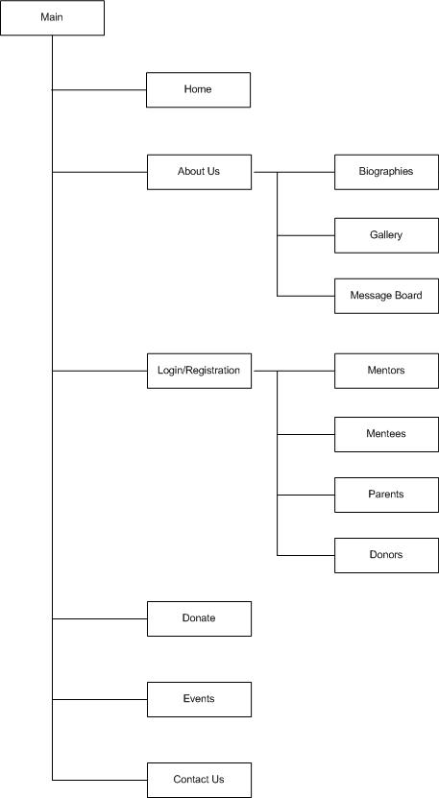

5.2 High Level Process Flows

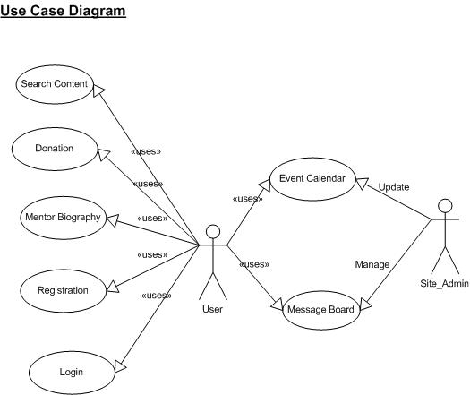

5.2.1 Registration (TR 4.1.)

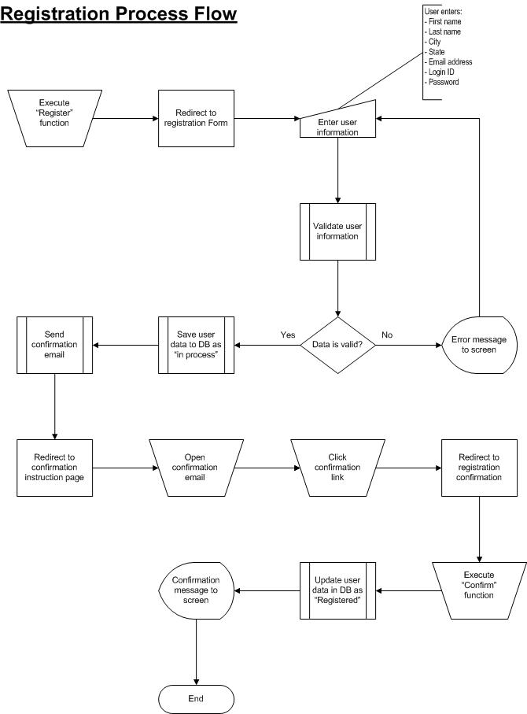
5.2.2 Login (TR 4.2)

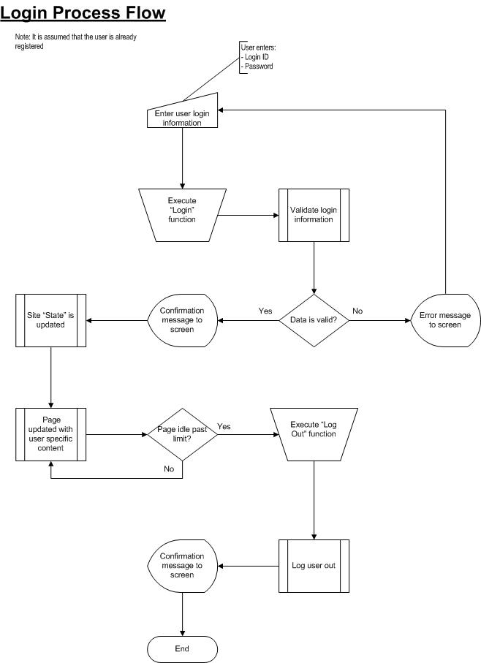

5.2.3 Calendar (TR 4.3)

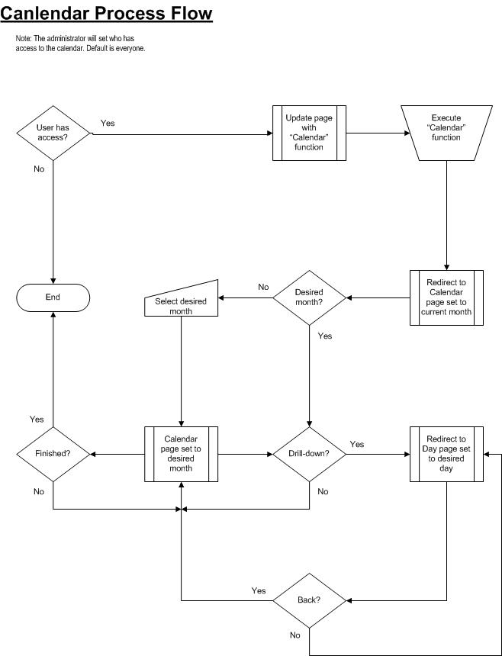
5.2.4 Search Content (TR 4.4)

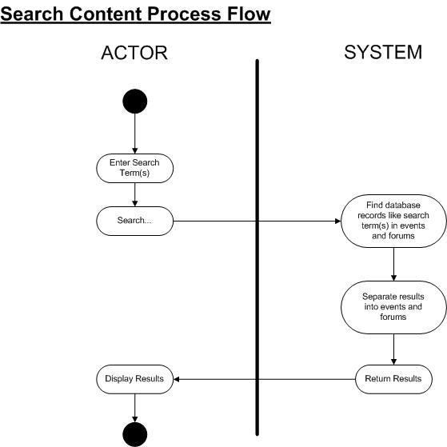

5.2.5 Message Board (TR 4.5)

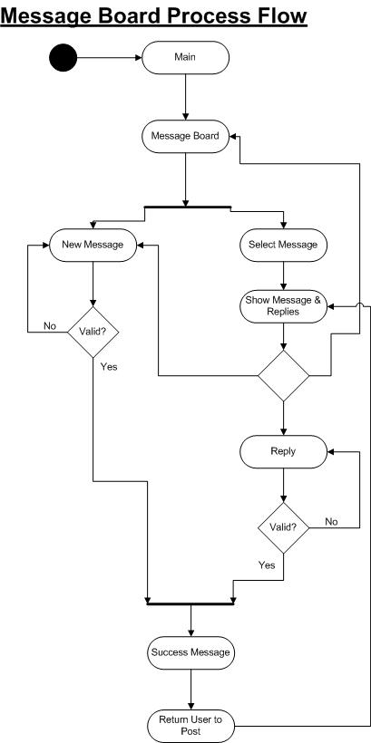

5.2.6 Donation (TR 4.6)

6. Interface Requirements/Specifications
6.1. User Interfaces
- The site will be optimized for 1024x768 screen resolution on all common browser/browser versions.

- The presentation layer including all main colors, fonts, and widths will be controlled by CSS.

User Interface Wireframe
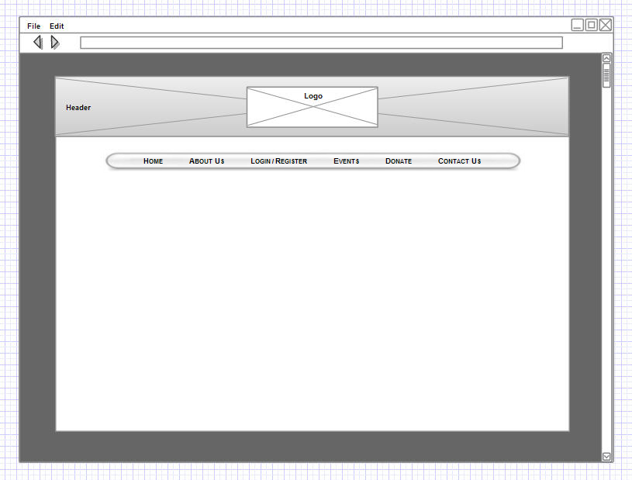

- Header: Topical image collage
- Menu: Consistent navigation menu

6.1.1 Home Page
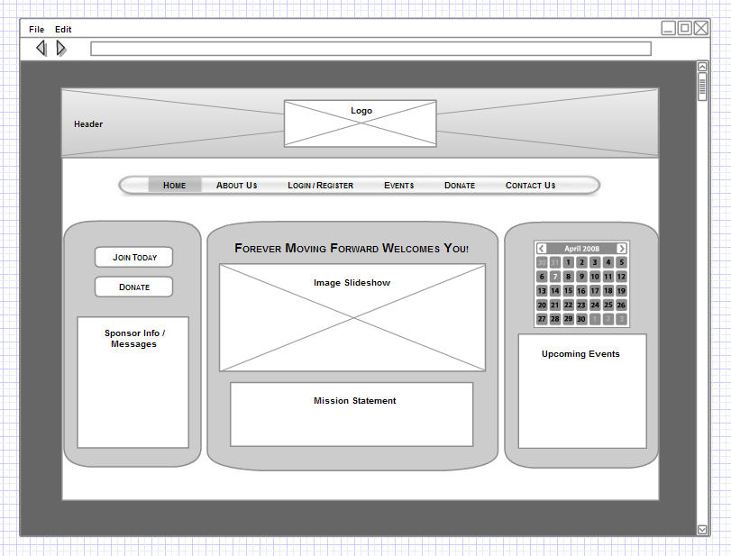

- Home/Main page is dashboard to pertinent visitor/member user information
- Left Pane Buttons: Navigational elements for membership/donation promotion
- Sponsor Info/Messages Box: Sponsorship information and/or logo or pertinent messages
- Calendar/Upcoming Events Pane: Used for event promotion, easy event lookup

6.1.2 Mentor Biography Wireframe
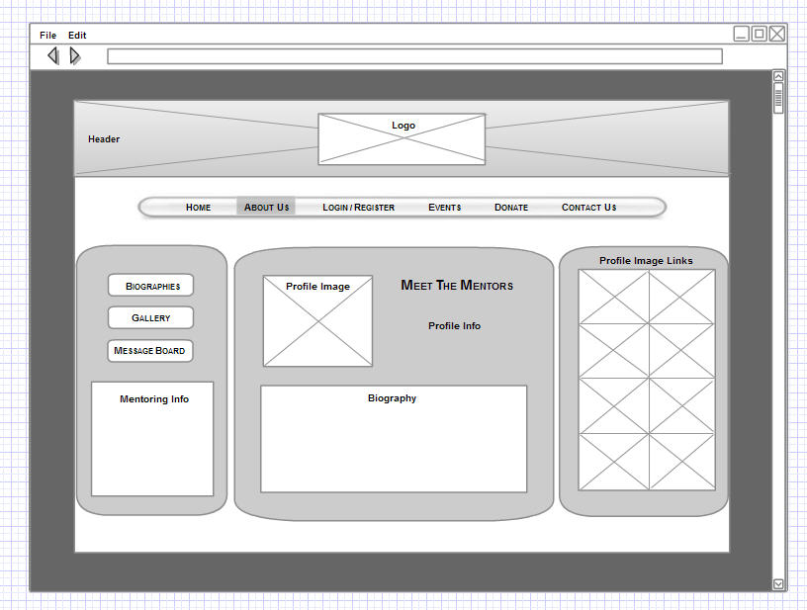

- Left Pane Buttons: Navigational elements for submenu items- mentor biographies, gallery of events and testimonials, and message board
- Mentoring Info Box: Information on becoming a mentor, value of mentoring, etc.
- Profile Image Links of Left Pane: Profile images used to link to individual mentor biographies

6.1.3 Calendar Event Wireframe
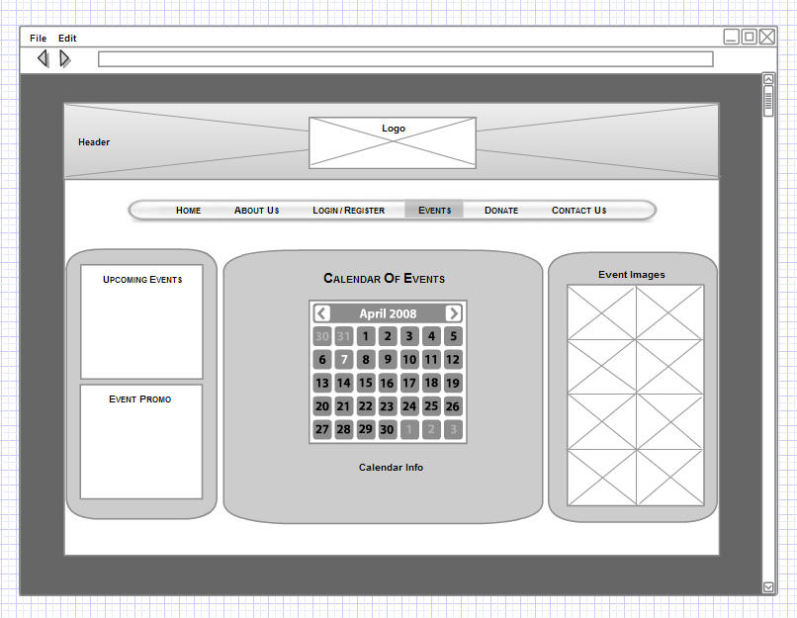

- Upcoming Events Box: List of current/upcoming events
- Event Promo Box: Event promotion
- Calendar of Events: Dynamic calendar of events, including links to Outlook scheduler download

6.2. Hardware Interfaces:
Apache 2 Web Server hosted by Blue Host
OC-48 Backbone

  - Software Interfaces:
Apache 2 Web Server
PGSQL Database Backend
CentOS Linux Operating System
PHP 5
  - Communication Interfaces:
XHTML 1.0 Strict
Javascript (Minimal, possibly jQuery library)
PHP 5

- Data Requirement

  - User table, including (mentees, mentors, donors and other visitors)
  - Donation table
7.3 Calendar event schedule table
7.4 Content management tables
7.5 Message tables for message board

- Non-Functional Requirements
  - Operational Requirements
8.1.1. Availability
      - 99.9% Uptime, available 24/7
      - <4s load time (exclude large forum posts from this time requirement) – Test with YSlow!

    - Capacity Requirements
      - Estimate 0 to 200 users to access the site at any time

    - Maintenance and Support Requirements
      - Site should run with minimal support needed, however, an email address for support shall be supplied on the website

  - Security Requirements
    - All input/output sanitized for Cross Site Scripting (XSS) and SQL Injections
    - PHP parameterized queries into the database
    - All passwords shall be sha1’d and salted prior to database entry
    - PHP/SQL exceptions shall not be displayed to the user
    - Sanitized data shall be white listed to the following list: 0-9, a-z, A-Z, !, @, #, $, %, *, (, ), -, +, =, {, }, [, ], :, ;, “, ‘, ,, ., ?, /
    - Data input that is not in the sanitized white list shown above shall be silently deleted prior to database entry
    - Unicode is translated across HTTP as character entity references in the form of &#1234; documented here: http://www.w3.org/TR/html4/sgml/entities.html - with our requirement of white listing and not allowing for the & character, the removal of it will remove any character reference as well. However, to make sure that all Unicode is removed, prior to sanitizing by our white list, we shall also remove any character entity references with the following regular expression: /\&\#?\d{2,}\;?/

  - Approval of Technical Requirements
    - Kristina Wu (Project Lead): 4/25/2010
    - Martha Fitt (Media/Graphic Designer): 4/25/2010
    - Jake Lake (DBA / Programmer): 4/25/2010
    - Patarika Tipwong, DBA / Programmer: 4/25/2010
    - Siebert Keith Hardeman, Programmer/Analyst: 4/25/2010
    - Adam Barr, Analyst: 4/25/2010

Contributions

Siebert Keith Hardeman
Managed and lead the conference call with client, wrote overview, objectives, created login process flow, registration process flow, calendar process flow

Martha Fitt
Created Information architecture, high level sitemap, and all the wireframes.

Jake Lake
Wrote hardware and software interfaces, non-functional requirements, created message board process flow, search process flow, converted to html and posted to ectweb

Patarika Tipwong
Wrote Data requirements, created donation process flow, help consolidated document

Adam Barr
Attended conference call; wrote Functional requirements

Kristina Wu
Coordinated work, created work breakdown, wrote Impact assessment, Implementation strategy, created use case diagram, consolidated team members’ work, attended conference call

Deliverable C Website

http://ectweb.cs.depaul.edu/green40/

